Nivelamento Basic 2

# Circle the correct answers.

* 1. Do you like **Ecuador / Ecuadorian** food?
  2. Is your grandfather from **Vietnam / Vietnamese?**
  3. My sister spoke **Italy / Italian** when she was on vacation.
  4. Did you see the pyramids in **Egypt / Egyptian?**
  5. I **do / play / go** karate.
  6. My mother is **doing / playing / going** biking

# Look at the picture. Circle the correct words in the questions.

# .

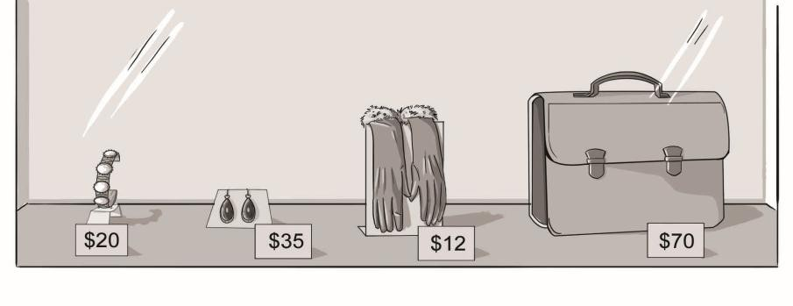

* 1. ***A*** How much **is this / are these** bracelet? c. ***A*** How much **is this / are these** gloves?

.

* 1. ***A*** How much **is that / are those** earrings? d. ***A*** How much **is that / are those** briefcase?

1. **Complete the paragraph. Use the *SIMPLE PAST* and the words in parentheses.**

Liz went (go) to the movies last evening. She wanted (want) to go to an outdoor concert, but it rained (rain), so she changed (change) her plans. After the movies, she ate (eat) a sandwich, studied (study) for a couple of hours. Then, it

was (be) time to go to bed. She slept (sleep) for 8 hours.

1. **Complete the paragraph. Use *WAS,* *WASN’T*, *WERE* or *WEREN’T*.**

I remember my first swimming lesson. I wasn´t very old – only five – and I was

very scared. I think the other kids were nervous, too. But the teacher, Julie,

was very nice. We loved her, but the swimming didn’t go very well. We

weren´t very good students, but Julie was a wonderful teacher.

# Complete the sentences with *GOT* or *WENT*.

* 1. Yesterday, I *WENT*. hiking with my friends. It was great, but it was really hot and sunny. I

*GOT* a bad sunburn.

* 1. I *WENT*. on a road trip across the U.S. with my brother. It was awful. We both

*GOT* sick! We had to stop and stay in bed for three days.

# Write the questions for the answers.

*Example: A: How was your vacation ?*

*B: My vacation? It was fun!*

*Opções:*

*Where did you go?*

*Who did you go with?*

*What was the weather like?*

*How long were you there?*

1. *A: Where did you go?*

*B*:We went to New York.

2. *A: Who did you go with?*

*B*: I went with my family.

3. *A: What was the weather like?*

*B:* It was rainy, but warm.

4. *A: How long were you there?*

*B:* We were there for a week.

# Circle the correct words. (0,5 each)

1. *A* How ***much*** / ***many*** fruit do you eat a day?

*B* Well, I have ***banana / a banana*** every day for breakfast.

1. *A* How ***many / much*** times a week do your parents eat meat?

*B* They eat ***beef / beefs*** almost every day.

1. *A* Does your brother eat ***many/ much*** eggs?

*B* No, he doesn’t. I bet he eats ***egg / eggs*** about once a month.

# Complete the questions and answers. Use *SOME* or *ANY*. (0,5 each)

* 1. *A* Do you have *ANY* fruit or snacks? I’m starving.

*B* No, but I have *SOME* milk. You can have that.

* 1. *A* It’s so hot. Do you want to come to our house? We have *SOME* ice cream.

*B* Sure. Do you have *ANY* sprinkles? I love sprinkles.